検索サイズ: 検索結果:324件
パターン | シリーズNo. | タイヤサイズ | 取付 | 構造 | 許容リム幅
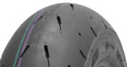 | 003  (SCF) | 100/90-12 49J | F | TL | 2.15～2.75
 | 003  (MCF) | 100/90-12 49J | F | TL | 2.15～2.75
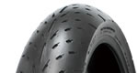 | 003  STEALTH | 120/60ZR17 M/C 55W | F | TL | 3.00～3.50
 | 003  STEALTH | 120/70ZR17 M/C 58W | F | TL | 3.00～3.50
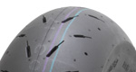 | 003  (MCR) | 120/80-12 55J | R | TL | 2.50～3.50
 | 003  (HCR) | 120/80-12 55J | R | TL | 2.50～3.50
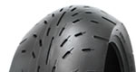 | 003  STEALTH | 150/60ZR17 M/C 66W | R | TL | 4.00～4.50
 | 003  STEALTH | 150/80ZR16 M/C 71W | R | TL | 3.50～4.50
 | 003  STEALTH | 180/55ZR17 M/C 73W | R | TL | 5.50～6.00
 | 003  STEALTH | 190/50ZR17 M/C 73W | R | TL | 5.50～6.00
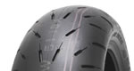 | 003A  HOOK UP (For Drag) | 180/55ZR17 M/C 73W | R | TL | 5.50～6.00
 | 003A  HOOK UP (For Drag) | 190/50ZR17 M/C 73W | R | TL | 5.50～6.00
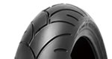 | 005  ADVANCE | 120/60ZR17 M/C 55W | F | TL | 3.00～3.50
 | 005  ADVANCE | 120/70-21 M/C 62V | F | TL | 3.00～3.50
 | 005  ADVANCE | 120/70ZR17 M/C 58W | F | TL | 3.00～3.50
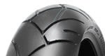 | 005  ADVANCE | 160/60ZR17 M/C 69W | R | TL | 4.50～5.00
 | 005  ADVANCE | 170/60ZR17 M/C 72W | R | TL | 4.50～5.50
 | 005  ADVANCE | 180/55ZR17 M/C 73W | R | TL | 5.50～6.00
 | 005  ADVANCE | 190/50ZR17 M/C 73W | R | TL | 5.50～6.00
 | 005  ADVANCE | 200/50ZR17 M/C 75W | R | TL | 6.00～6.50
 | 005  ADVANCE | 240/40R18 M/C 79V | R | TL | 8.00～9.00
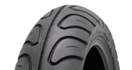 | 006  PODIUM | 110/70R17 M/C 54V | F | TL | 2.75～3.50
 | 006  PODIUM | 130/70ZR16 M/C 61W | F | TL | 3.50～4.00
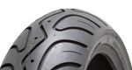 | 006  PODIUM | 140/60R17 M/C 63V | R | TL | 3.50～4.50
 | 006  PODIUM | 140/60R18 M/C 66V | R | TL | 3.50～4.50
 | 006  PODIUM | 150/60R17 M/C 66V | R | TL | 4.00～4.50
 | 006  PODIUM | 150/60R18 M/C 67V | R | TL | 4.00～4.50
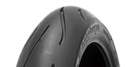 | 010  APEX | 120/60ZR17 M/C (55W) | F | TL | 3.00～3.50
 | 010  APEX | 120/70ZR17 M/C (58W) | F | TL | 3.00～3.50
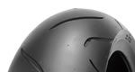 | 010  APEX | 150/60ZR17 M/C (66W) | R | TL | 4.00～4.50
 | 010  APEX | 160/60ZR17 M/C (69W) | R | TL | 4.50～5.00
 | 010  APEX | 170/60ZR17 M/C (72W) | R | TL | 4.50～5.50
 | 010  APEX | 180/55ZR17 M/C (73W) | R | TL | 5.50～6.00
 | 010  APEX | 190/50ZR17 M/C (73W) | R | TL | 5.50～6.00
 | 010  APEX | 190/55ZR17 M/C (75W) | R | TL | 5.50～6.00
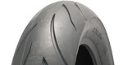 | 011  VERGE | 120/60ZR17 M/C (55W) | F | TL | 3.00～3.50
 | 011  VERGE | 120/70ZR17 M/C (58W) | F | TL | 3.00～3.50
 | 011  VERGE | 140/75VR17 M/C (67V) | F | TL | 3.50～4.25
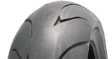 | 011  VERGE | 160/60ZR17 M/C (69W) | R | TL | 4.50～5.00
 | 011  VERGE | 170/60ZR17 M/C (72W) | R | TL | 4.50～5.50
 | 011  VERGE | 180/55ZR17 M/C (73W) | R | TL | 5.50～6.00
 | 011  VERGE | 190/50ZR17 M/C (73W) | R | TL | 5.50～6.00
 | 011  VERGE | 200/50ZR17 M/C (75W) | R | TL | 5.50～6.00
 | 011  VERGE | 200/55VR17 M/C (78V) | R | TL | 6.00～6.50
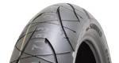 | 016  VERGE 2X | 120/60ZR17 M/C (55W) | F | TL | 3.00～3.50
 | 016  VERGE 2X | 120/70ZR17 M/C (58W) | F | TL | 3.00～3.50
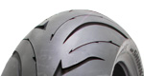 | 016  VERGE 2X | 160/60ZR17 M/C (69W) | R | TL | 4.50～5.00
 | 016  VERGE 2X | 180/55ZR17 M/C (73W) | R | TL | 5.50～6.00
 | 016  VERGE 2X | 190/50ZR17 M/C (73W) | R | TL | 5.50～6.00
 | 016  VERGE 2X | 190/55ZR17 M/C (75W) | R | TL | 5.50～6.00
 | 110  SPORT MASTER-PRO | 100/90-19 M/C 57V | F | TL | 2.15～2.75
 | 110  SPORT MASTER-PRO | 110/90-18 M/C 61V | F | TL | 2.15～3.00
 | 110  SPORT MASTER-PRO | 120/90-18 M/C 71V | R | TL | 2.50～3.00
 | 110  SPORT MASTER-PRO | 130/80-18 M/C 66V | R | TL | 2.50～3.50
 | 110  SPORT MASTER-PRO | 130/90-17 M/C 74V | R | TL | 2.50～3.50
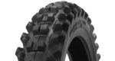 | 216MX | 80/100-21 51R | F | TT | 1.60～2.15
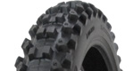 | 216MX | 90/100-21 54R | F | TT | 1.85～2.50
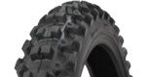 | 216MX | 90/90-21 54R | F | TT | 1.85～2.50
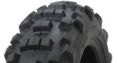 | 216MX | 110/100-18 64R | R | TT | 2.15～2.75
 | 216MX | 110/90-19 62R | R | TT | 2.15～2.75
 | 216MX | 120/100-18 68R | R | TT | 2.15～2.75
 | 216MX | 120/90-18 65R | R | TL | 2.15～2.75
 | 216MX | 120/90-19 66R | R | TT | 2.15～2.75
 | 216MX | 140/80-18 70R | R | TL | 2.75～3.75
 | 216SX | 140/80-18 70R | R | TL | 2.75～3.75
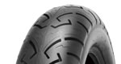 | 250 | MT90-16 M/C 73H | F | TL | 3.00
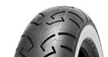 | 250 | MT90-16 M/C 73H (WW) | F | TL | 3.00
 | 250 | MT90-16 M/C 74H | R | TL | 3.00
 | 250 | MT90-16 M/C 74H (WW) | R | TL | 3.00
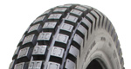 | 255  TRAIL PRO | 110/90R18 M/C 61L | R | TL | 2.15～3.00
 | 280  SPORT MASTER | 100/80-17 M/C 52V | F | TL | 2.15～2.75
 | 280  SPORT MASTER | 100/90-16 M/C 54V | F | TL | 2.15～2.75
 | 280  SPORT MASTER | 110/70-17 M/C 54V | F | TL | 2.75～3.50
 | 280  SPORT MASTER | 120/80-17 M/C 61V | R | TL | 2.50～3.00
 | 280  SPORT MASTER | 140/70-17 M/C 66V | R | TL | 3.50～4.50
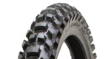 | 520A  HOLESHOT IT | 70/100-19 42M | F | TT | -
 | 520A  HOLESHOT IT | 80/100-21 51W | F | TT | -
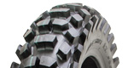 | 520A  HOLESHOT IT | 100/90-19 57M | R | TT | -
 | 520A  HOLESHOT IT | 110/100-18 64W | R | TT | -
 | 520A  HOLESHOT IT | 110/90-19 62M | R | TT | -
 | 520A  HOLESHOT IT | 120/100-18 68M | R | TT | -
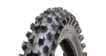 | 540  HOLESHOT MS | 70/100-17 40W | F | TT | -
 | 540  HOLESHOT MS | 70/100-19 42M | F | TT | -
 | 540  HOLESHOT MS | 80/100-21 51W | F | TT | -
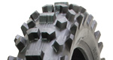 | 540  HOLESHOT MS | 100/100-18 59M | R | TT | -
 | 540  HOLESHOT MS | 100/90-19 57M | R | TT | -
 | 540  HOLESHOT MS | 110/100-18 64M | R | TT | -
 | 540  HOLESHOT MS | 110/90-19 62M | R | TT | -
 | 540  HOLESHOT MS | 120/100-18 68M | R | TT | -
 | 540  HOLESHOT MS | 120/90-19 66M | R | TT | -
 | 540  HOLESHOT MS | 90/100-14 49M | R | TT | -
 | 540  HOLESHOT MS | 90/100-16 51M | R | TT | -
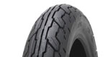 | 610 | 3.50-18 M/C 56H | F/R | TL | 1.85～2.50
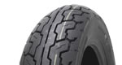 | 610 | 4.00-18 M/C 64H | F/R | TL | 2.15～3.00
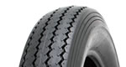 | E240 | 100/90-19 63H | F | TL | 1.85～2.75
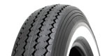 | E240 | 100/90-19 63H (WW) | F | TL | 1.85～2.75
 | E240 | MT90-16 M/C 74H | F/R | TT | 3.00
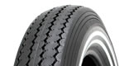 | E240 | MT90-16 M/C 74H (W-2) | F/R | TT | 3.00
 | E240 | MT90-16 M/C 74H (WW) | F/R | TT | 3.00
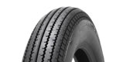 | E270 | 3.00-21 57S | F | TT | 1.60～2.15
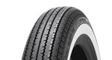 | E270 | 3.00-21 57S (WW) | F | TT | 1.60～2.15
 | E270 | 4.00-19 61H | F | TT | 2.15～2.50
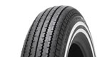 | E270 | 4.00-19 61H (W-2) | F | TT | 2.15～2.50
 | E270 | 4.00-19 61H (WW) | F | TT | 2.15～2.50
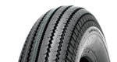 | E270 | 4.00-18 64H | F/R | TT | 2.15～2.50
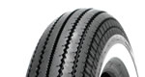 | E270 | 4.00-18 64H (WW) | F/R | TT | 2.15～2.50
 | E270 | 5.00-16 69S | F/R | TT | 3.00
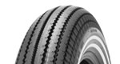 | E270 | 5.00-16 69S (W-2) | F/R | TT | 3.00
 | E270 | 5.00-16 69S (WW) | F/R | TT | 3.00
 | E270 | 4.50-18 70H | R | TT | 2.15～3.00
 | E270 | 4.50-18 70H (WW) | R | TT | 2.15～3.00
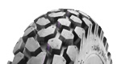 | E700 | 130/80-18 M/C 66S | F/R | TL | 2.50～3.50
 | E700 | 3.00－21 M/C 51S | F/R | TL | 1.60～2.15
 | E700 | 4.60-17 M/C 62P | F/R | TT | 2.15～2.75
 | E700 | 4.60-18 M/C 63S | F/R | TT | 2.15～2.75
 | E700 | 5.10-17 M/C 67S | F/R | TL | 2.50～4.00
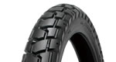 | E705 | 110/80-19 M/C 59Q | F | TL | 2.15～3.00
 | E705 | 110/80R19 M/C 59H | F | TL | 2.15～3.00
 | E705 | 120/70R17 M/C 58H | F | TL | 3.00～3.50
 | E705 | 120/70R19 M/C 60H | F | TL | 3.00～3.50
 | E705 | 2.75-21 45P | F | TT | 1.40～1.85
 | E705 | 90/90-21 M/C 54H | F | TL | 1.85～2.50
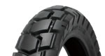 | E705 | 130/80-17 M/C 65H | R | TL | 2.50～3.50
 | E705 | 150/70-17 M/C 69Q | R | TL | 3.50～4.50
 | E705 | 150/70R17 M/C 69H | R | TL | 3.50～4.50
 | E705 | 170/60R17 M/C 72H | R | TL | 4.50～5.50
 | E705 | 4.10-18 59P | R | TT | 1.85～2.50
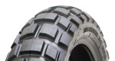 | E804 | 100/90-19 M/C 57S | F | TT | 2.15～3.00
 | E804 | 110/80B19 M/C 59Q | F | TL | 2.15～3.00
 | E804 | 110/80R19 M/C 59R | F | TL | 2.15～3.00
 | E804 | 120/70R19 M/C 60H | F | TL | 3.50～3.75
 | E804 | 90/90-21 M/C 54T | F | TL | 1.85～2.50
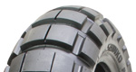 | E805 | 120/90-18 M/C 65R | R | TT | 2.50～3.00
 | E805 | 130/80-17 M/C 65T | R | TL | 2.50～3.50
 | E805 | 140/80-17 M/C 65Q | R | TT | 2.75～3.75
 | E805 | 140/80-18 M/C 70R | R | TT | 3.50～3.75
 | E805 | 150/70B17 M/C 69Q | R | TL | 3.50～4.50
 | E805 | 150/70B18 M/C 70Q | R | TL | 3.50～4.50
 | E805 | 170/60R17 M/C 72H | R | TL | 4.25～5.50
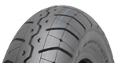 | F230  TOUR MASTER | 100/90-19 M/C 61V | F | TL | 2.15～3.00
 | F230  TOUR MASTER | 110/90-18 M/C 61V | F | TL | 2.15～3.00
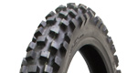 | F504  HOLESHOT HT | 120/70-12 51P | F | TL | 2.50～3.50
 | F504  HOLESHOT HT | 80/100-21 51M | F | TT | -
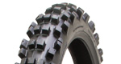 | F524  HOLESHOT ST | 70/100-17 40W | F | TT | -
 | F524  HOLESHOT ST | 70/100-19 42W | F | TT | -
 | F524  HOLESHOT ST | 80/100-21 51W | F | TT | -
 | F524HF  HIGH FIDELITY | 80/100-21 51M | F | TT | -
 | F524X  X-compound | 70/100-19 42M | F | TT | -
 | F524X  X-compound | 80/100-21 51M | F | TT | -
 | F540HF  HIGH FIDELITY | 80-100-21 51M | F | TT | -
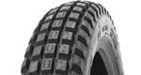 | F544 | 2.75-21 45L | F | TT | -
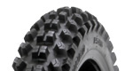 | F546  HOLESHOT ST | 70/100-19 42M | F | TT | -
 | F546  HOLESHOT ST | 80/100-21 51M | F | TT | -
 | F546  HOLESHOT ST | 90/100-21 57M | F | TT | -
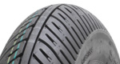 | F613 | 100/90-12 49J | F | TL | 2.15～2.75
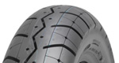 | R230  TOUR MASTER | 120/90-18 M/C 71V | R | TL | 2.50～3.00
 | R230  TOUR MASTER | 130/90-17 M/C 74V | R | TL | 2.50～3.50
 | R230  TOUR MASTER | 130/90-18 M/C 69V | R | TL | 2.50～3.50
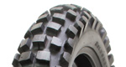 | R505  HOLESHOT HT | 100/100-18 59W | R | TT | -
 | R505  HOLESHOT HT | 100/90-19 57M | R | TT | -
 | R505  CHEATER | 110/100-18 64M | R | TT | -
 | R505  HOLESHOT HT | 110/100-18 64W | R | TT | -
 | R505  HOLESHOT HT | 110/90-19 62M | R | TT | -
 | R505  CHEATER | 110/90-19 62M | R | TT | -
 | R505  CHEATER | 120/100-18 68M | R | TT | -
 | R505  HOLESHOT HT | 120/90-19 66M | R | TT | -
 | R505  CHEATER | 120/90-19 66M | R | TT | -
 | R505  HOLESHOT HT | 130/70-12 56P | R | TL | 2.50～3.50
 | R520DC  DUAL COMPOUND | 120/100-18 68M | R | TT
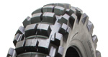 | R525  HOLESHOT ST | 100/100-18 59M | R | TT | -
 | R525  HOLESHOT ST | 100/90-19 57M | R | TT | -
 | R525  CHEATER | 110/100-18 64M | R | TT | -
 | R525  HOLESHOT ST | 110/100-18 64M | R | TT | -
 | R525  HOLESHOT ST | 110/90-19 62M | R | TT | -
 | R525  CHEATER | 110/90-19 62M | R | TT | -
 | R525  HOLESHOT ST | 120/100-18 68M | R | TT | -
 | R525  CHEATER | 120/100-18 68M | R | TT | -
 | R525  CHEATER | 120/90-19 66M | R | TT | -
 | R525  HOLESHOT ST | 120/90-19 66M | R | TT | -
 | R525  HOLESHOT ST | 90/100-14 49W | R | TT | -
 | R525  HOLESHOT ST | 90/100-16 51M | R | TT | -
 | R525X  X-compound | 110/100-18 64M | R | TT | -
 | R525X  X-compound | 120/100-18 68M | R | TT | -
 | R525X  X-compound | 90/100-16 51M | R | TT | -
 | R540DC  DUAL COMPOUND | 110/100-18 64M | R | TT | -
 | R540DC  DUAL COMPOUND | 120/100-18 68M | R | TT | -
 | R540X  X-compound | 120/100-18 68M | R | TT | -
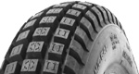 | R545 | 4.00R18 64L | R | TL | -
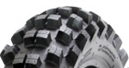 | R546  HOLESHOT ST | 100-90-19 57M | R | TT | -
 | R546  HOLESHOT ST | 100/100-18 59M | R | TT | -
 | R546  HOLESHOT ST | 110/100-18 64M | R | TT | -
 | R546  CHEATER | 110/100-18 64M | R | TT | -
 | R546  HOLESHOT ST | 110/90-19 62M | R | TT | -
 | R546  HOLESHOT ST | 120/100-18 68M | R | TT | -
 | R546  HOLESHOT ST | 120/80-19 63M | R | TT | -
 | R546  HOLESHOT ST | 90/100-16 51M | R | TT | -
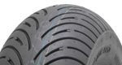 | R614 | 120/80-12 55J | R | TL | 2.50～2.75
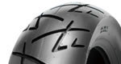 | SR009 | 110/70-12 47J | F/R | TL | 2.50～3.50
 | SR009 | 120/70-12 51J | F/R | TL | 2.75～3.50
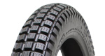 | SR241  TRAIL | 2 3/4-17 47J (2.75-17相当) | F/R | TT | 1.40～1.85
 | SR241  TRAIL | 2.50-17 38L | F/R | TT | 1.40～1.60
 | SR241  TRAIL | 2.75-14 35P | F/R | TT | 1.40～1.85
 | SR241  TRAIL | 2.75-19 43P | F/R | TT | 1.40～1.85
 | SR241  TRAIL | 2.75-21 45P | F/R | TT | 1.40～1.85
 | SR241  TRAIL | 3.00-16 43P | F/R | TT | 1.40～1.85
 | SR241  TRAIL | 3.00-17 45P | F/R | TT | 1.60～2.15
 | SR241  TRAIL | 3.00-21 51P | F/R | TT | 1.60～2.15
 | SR241  TRAIL | 3.50-18 56P | F/R | TT | 1.85～2.50
 | SR241  TRAIL | 4.00-18 64P | F/R | TT | 2.15～3.00
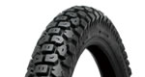 | SR244 | 2.75-21 45P | F | TT | 1.40～1.85
 | SR244 | 3.00-21 51L | F | TT | 1.60～2.15
 | SR244 | 4.60-17 62P | F | TT | 2.15～2.75
 | SR244 | 2.50-17 38L | F/R | TT | 1.40～1.60
 | SR244 | 3.00-17 45P | F/R | TT | 1.60～2.15
 | SR244 | 3.25-17 50P | F/R | TT | 1.85～2.15
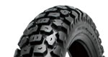 | SR244 | 4.10-18 60S | R | TT | 1.85～2.50
 | SR244 | 4.60-18 63P | R | TT | 2.15～2.75
 | SR244 | 5.10-17 67P | R | TT | 2.50～4.00
 | SR244 | 5.10-18 69P | R | TT | 2.50～4.00
 | SR248 | 3.00-21 51P | F | TT | 1.60～2.15
 | SR248 | 4.60-18 63P | R | TT | 2.15～2.75
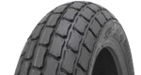 | SR267 | 130/80-19 67H | F | TT | 3.00～3.50
 | SR267 | 120/70-17 59M | F/R | TT | 2.50～3.50
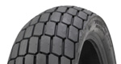 | SR268 | 140/80-19 71H | R | TT | 3.50～4.50
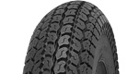 | SR402 | 3.50-8 45J | F/R | TT | 1.85～2.15
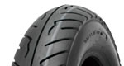 | SR412 | 3.00-10 42J | F/R | TL | 1.85～2.15
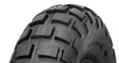 | SR421 | 3.50-8 46J | F/R | TT | 2.15
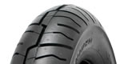 | SR425 | 120/90-10 66J | F/R | TL | 2.75～3.50
 | SR425 | 3.00-10 42J | F/R | TL | 1.85～2.15
 | SR425 | 3.50-10 51J | F/R | TL | 2.15～2.50
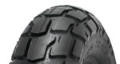 | SR426 | 120/90-10 66J | F/R | TL | 2.75～3.50
 | SR426 | 130/90-10 70J | F/R | TL | 3.00～3.50
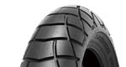 | SR428 | 130/80-18 M/C 66P | F | TT | 2.50～3.50
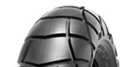 | SR428 | 180/80-14 M/C 78P | R | TT | 4.00～5.00
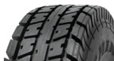 | SR510 | 5.4-6 (130/90-6 相当) | R | TT | 4.00
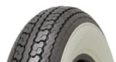 | SR550 | 3.00-10 50J (WW) | F/R | TT | 1.85～2.15
 | SR550 | 3.50-10 59J (WW) | F/R | TT | 2.15～2.50
 | SR550 | 3.50-8 46J (WW) | F/R | TT | 2.15
 | SR550 | 4.00-8 55J (WW) | F/R | TT | 2.50
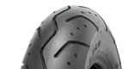 | SR560 | 3.50-10 51J | F/R | TL | 2.15～2.50
 | SR560 | 80/90-10 44J | F/R | TL | 1.85～2.15
 | SR560 | 90/90-10 50J | F/R | TL | 2.15～2.50
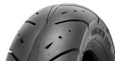 | SR561 | 100/90-10 56J | F/R | TL | 2.15～2.75
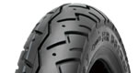 | SR561 | 80/100-10 46J | F/R | TL | 1.85～2.15
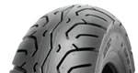 | SR562 | 100/90-10 56J | F/R | TL | 2.15～2.75
 | SR562 | 110/90-10 51J | F/R | TL | 2.15～2.75
 | SR562 | 90/90-12 44J | F/R | TL | 1.85～2.50
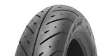 | SR563 | 90/90-14 M/C 46P | F | TL | 1.85～2.50
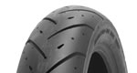 | SR563 | 100/90-14 M/C 51P | R | TL | 2.15～2.75
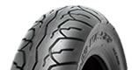 | SR567 | 110/90-12 64P | F | TL | 2.15～2.75
 | SR567 | 110/90-13 M/C 56P | F | TL | 2.15～3.00
 | SR567 | 120/70-13 M/C 53P | F | TL | 2.75～3.50
 | SR567 | 120/70-14 M/C 55S | F | TL | 2.75～3.50
 | SR567 | 120/80-14 M/C 58S | F | TL | 2.50～3.00
 | SR567 | 80/90-14 43P | F | TL | 1.85～2.15
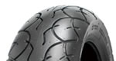 | SR568 | 130/70-12 62P | R | TL | 3.00～3.50
 | SR568 | 130/70-13 M/C 63P | R | TL | 3.00～4.00
 | SR568 | 140/70-12 65P | R | TL | 3.50～4.50
 | SR568 | 150/70-13 M/C 64S | R | TL | 3.50～4.50
 | SR568 | 150/70-14 M/C 66S | R | TL | 3.50～4.50
 | SR568 | 90/90-14 46P | R | TL | 2.15～2.50
 | SR570 | 120/70-13 M/C 53S | F | TL | 2.75～3.50
 | SR571 | 140/60-14 M/C 64S | R | TL | 3.50～4.50
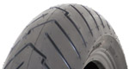 | SR615 | 110/70-13 48P | F | TL | 2.50～3.50
 | SR615 | 120/70R14 55H | F | TL | 3.50～3.75
 | SR615 | 120/70R15 56H JLSB | F | TL | 3.50～3.75
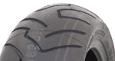 | SR615 | 130/70-13 57P | R | TL | 3.00～4.00
 | SR615 | 160/60R14 65H JLSB | R | TL | 4.25～5.00
 | SR615 | 160/60R15 67H JLSB | R | TL | 4.25～5.00
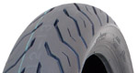 | SR616 | 100/80-14 48P | F | TL | 2.50～2.75
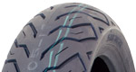 | SR616 | 120/70-14 61P | R | TL | 3.50～3.75
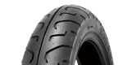 | SR712 | 100/90-19 M/C 57H | F | TL | 2.15～2.75
 | SR712 | 120/80-16 M/C 60H | F | TL | 2.50～3.00
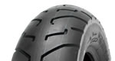 | SR712 | 140/90-15 M/C 70H | R | TL | 2.75～3.50
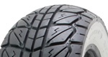 | SR723 | 120/70－12 58P (WW) | F | TL | 2.75～3.50
 | SR723 | 120/70-10 54P (WW) | F | TL | 2.75～3.50
 | SR723 | 110/70-12 47P (WW) | F/R | TL | 2.50～3.50
 | SR723 | 130/70-12 62P (WW) | R | TL | 3.00～3.50
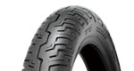 | SR733 | 100/90-19 M/C 57H | F | TL | 2.15～2.75
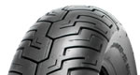 | SR734 | 130/90-15 M/C 66P | R | TL | 2.50～3.50
 | SR734 | 150/80-15 M?C 70S | R | TL | 3.00～4.00
 | SR734 | 170/80-15 M?C 77H | R | TL | 3.50～4.50
 | SR735 | 110/90-16 M/C 59S | F | TL | 2.15～3.00
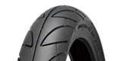 | SR740 | 110/70-17 M/C 54H | F | TL | 2.75～3.50
 | SR740 | 110/80-17 M/C 58V | F | TL | 2.15～3.00
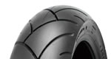 | SR741 | 130/70-17 M/C 62H | R | TL | 3.00～4.00
 | SR741 | 140/70-17 M/C 66H | R | TL | 3.50～4.50
 | SR741 | 140/70-18 M/C 63V | R | TL | 3.50～4.50
 | SR741 | 150/70-17 M/C 69H | R | TL | 3.50～4.50
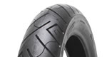 | SR777 | 100/90-19 M/C 61H | F | TL | 2.15～2.75
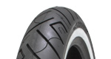 | SR777 | 100/90-19 M/C 61H(WW) | F | TL | 2.15～2.75
 | SR777 | 120/70-21 M/C 68V | F | TL | 2.75～3.75
 | SR777 | 120/70-21 M/C 68V(WW) | F | TL | 2.75～3.75
 | SR777 | 120/90-17 M/C 64H | F | TL | 2.50～3.00
 | SR777 | 130/60B19 M/C 67H | F | TL | 3.00～4.00
 | SR777 | 130/60B19 M/C 67H(WW) | F | TL | 3.00～4.00
 | SR777 | 130/80-17 M/C 65H | F | TL | 2.50～3.50
 | SR777 | 130/80-17 M/C 65H(WW) | F | TL | 2.50～3.50
 | SR777 | 130/90B16 M/C 73H | F | TL | 2.50～3.50
 | SR777 | 130/90B16 M/C 73H(WW) | F | TL | 2.50～3.00
 | SR777 | 80/90-21 M/C 54H | F | TL | 1.60～2.15
 | SR777 | 90/90-21 M/C 54H | F | TL | 1.85～2.50
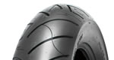 | SR777 | 130/90B16 M/C 73H | R | TL | 2.50～3.50
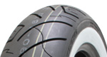 | SR777 | 130/90B16 M/C 73H(WW) | R | TL | 2.50～3.50
 | SR777 | 140/70B18 M/C 72H(WW) | R | TL | 3.50～4.50
 | SR777 | 140/90B16 M/C 77H | R | TL | 2.75～3.50
 | SR777 | 150/70B18 M/C 76H(WW) | R | TL | 3.50～4.50
 | SR777 | 150/80B16 M/C 77H | R | TL | 3.00～4.00
 | SR777 | 150/80B16 M/C 77H(WW) | R | TL | 3.00～4.00
 | SR777 | 160/70-17 M/C 79H | R | TL | 3.50～4.50
 | SR777 | 160/70-17 M/C 79H(WW) | R | TL | 3.50～4.50
 | SR777 | 160/80-15 M/C 74H | R | TL | 3.50～4.50
 | SR777 | 170/80B15 M/C 83H | R | TL | 3.50～4.50
 | SR777 | 170/80B15 M/C 83H(WW) | R | TL | 3.50～4.50
 | SR777 | 180/55B18 M/C 84H | R | TL | 5.50～6.00
 | SR777 | 180/65B16 M/C 81H | R | TL | 4.25～5.50
 | SR777 | 180/65B16 M/C 81H(WW) | R | TL | 4.25～5.50
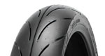 | SR780 | 110/70-17 M/C 58H | F | TL | 2.75～3.50
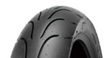 | SR781 | 130/70-17 M/C 62H | R | TL | 3.00～4.00
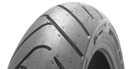 | SR880 | 110/70R17 M/C 54V | F | TL | 2.75～3.50
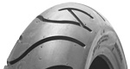 | SR881 | 140/70R17 M/C 66V | R | TL | 3.50～4.50
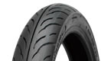 | SR898 | 100/80-17 M/C 52S | F/R | TL | 2.15～2.75
 | SR898 | 80/90-17 M/C 44P | F/R | TL | 1.85～2.15
 | SR898 | 90/80-17 M/C 46P | F/R | TL | 1.85～2.50

